
Total marks  35 | % | Weight  10%
My Target: ____ /35 or _____%  

Name: ______

Yr 7 Humanities & Social Sciences:

Task Seven:

Civics and Citizenship

Assessment 7: Homework Task (10%)

Civics and Citizenship: A series of questions to be completed by students, in relation to current course content.

Due Date: __________May 2017

Instructions:
- Please attempt all questions.
- Look at the question and determine if the space provided is requiring a full sentence answer.
- Remember to include examples where appropriate – Please avoid stating e.g. and use “for example”. If you use examples, remember to include examples within your explanation, instead of simply adding the example to the end.

- On the following map of Australia colour the states and territories of Australia using the following colouring scheme: unicameral states/territories in blue and bicameral states/territories in red.
(8 marks)
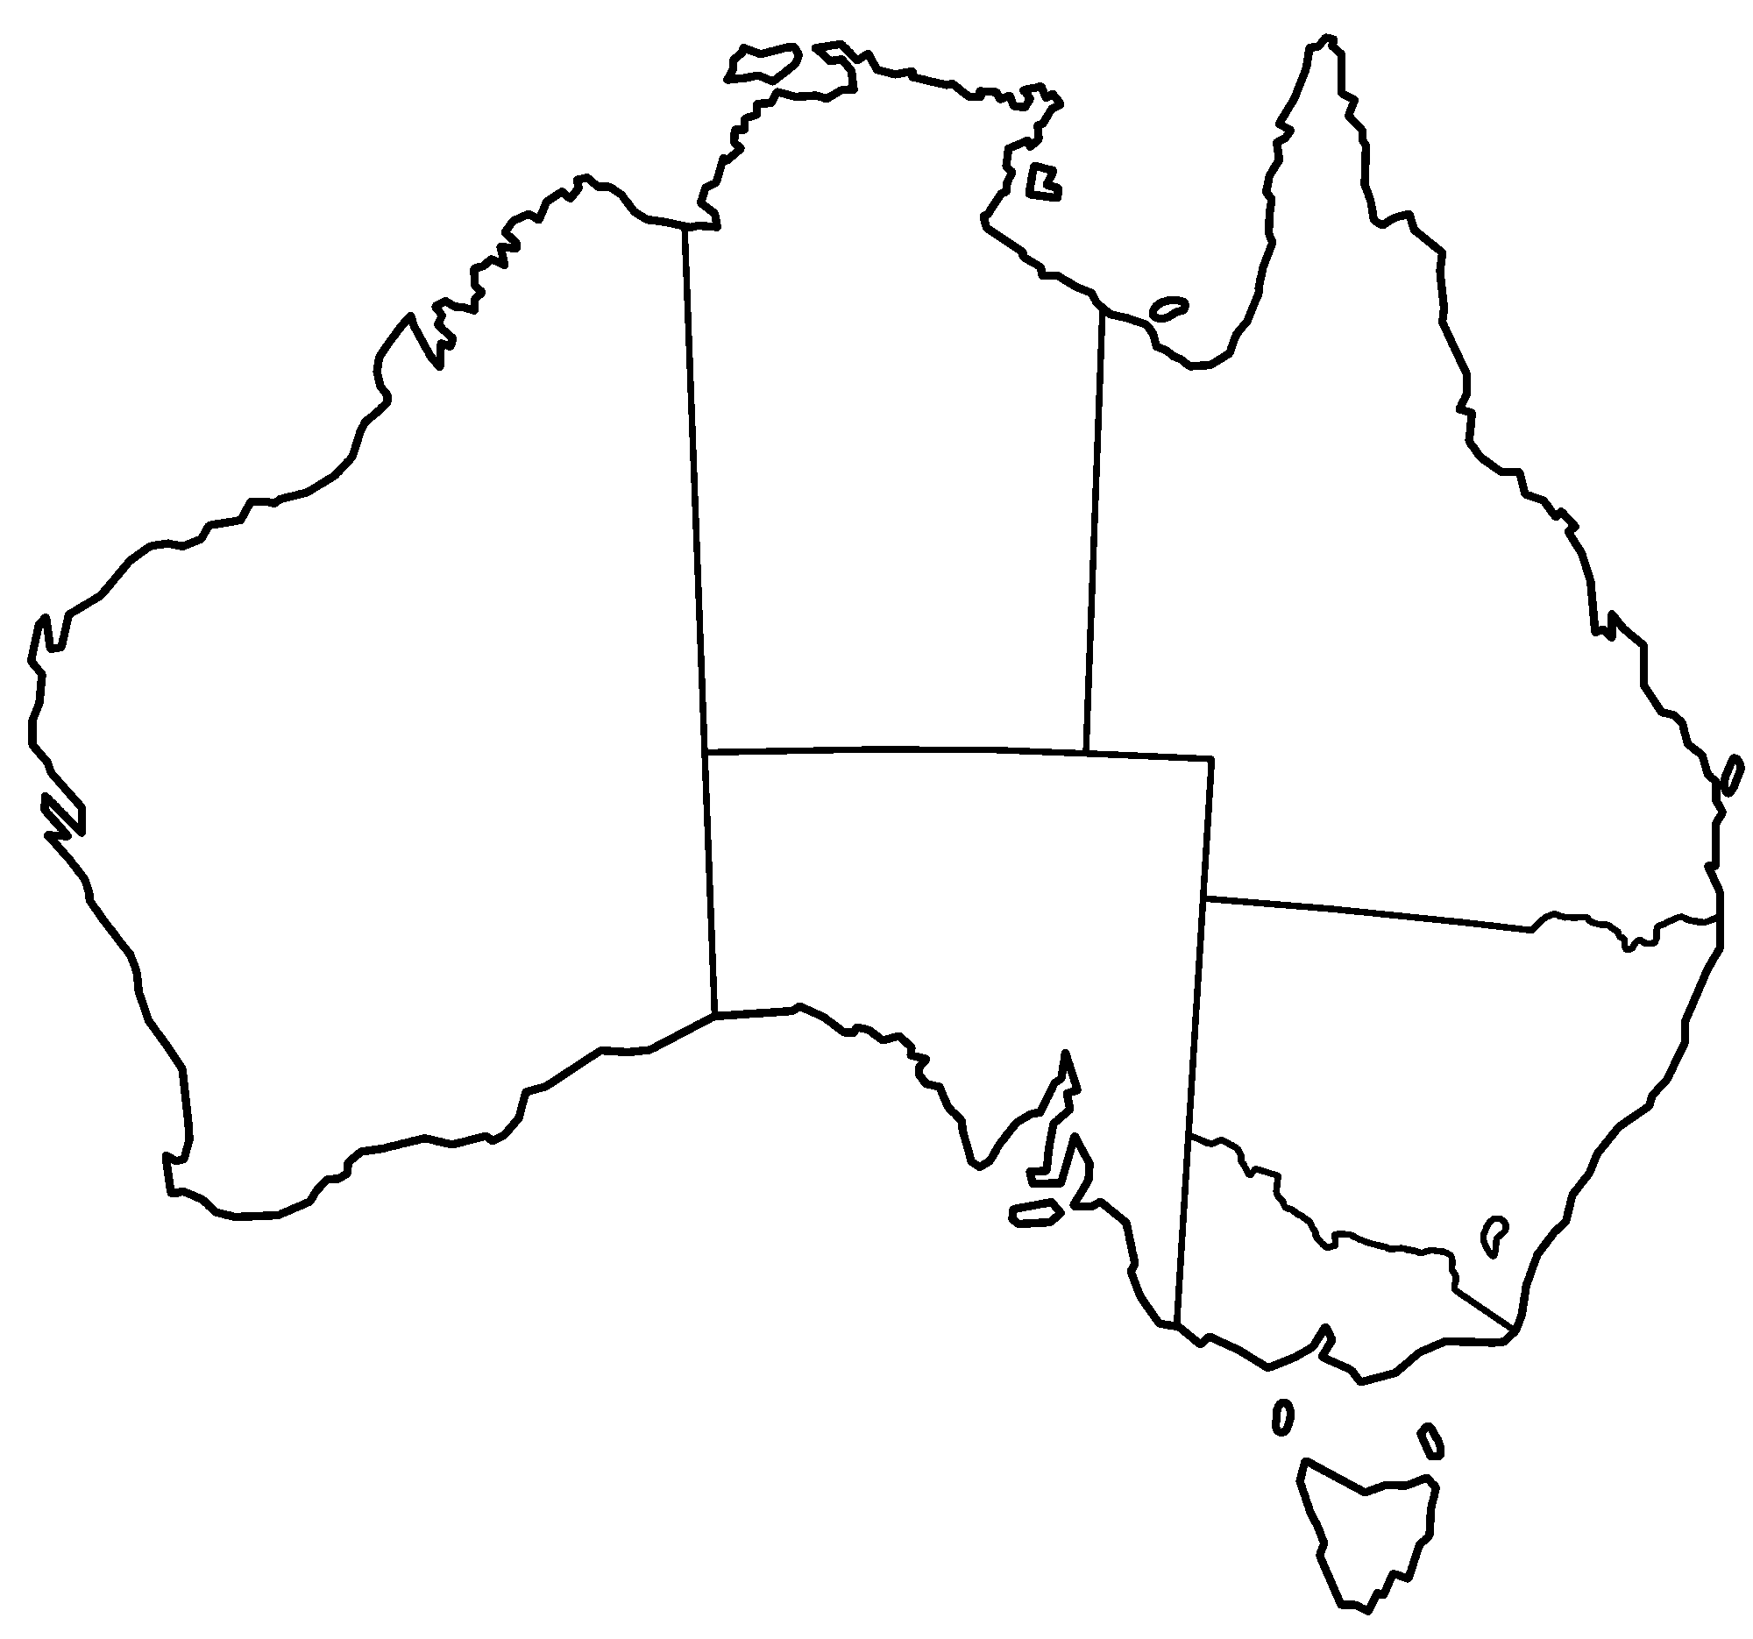
State/ territory
- List the eight states and territories of Australia and indicate whether they are bicameral or unicameral
(16 marks)
- Define the term bicameral. A good answer will use full sentences and includes relevant examples.
____________________________________________________________________________
____________________________________________________________________________
(2 marks)
- Define the term unicameral. A good answer will use full sentences and includes relevant examples.
____________________________________________________________________________
____________________________________________________________________________
(2 marks)
- Outline two key features of the Senate
Key feature 1: ______________________________________________________________
__________________________________________________________________________

Key feature 2: ______________________________________________________________
__________________________________________________________________________

(2 marks)

- Outline two key features of the House of Representatives

Key feature 1: ______________________________________________________________
__________________________________________________________________________

Key feature 2: ______________________________________________________________
__________________________________________________________________________
- marks)

- Describe why Australia uses the Westminster System of Government. A good answer will use full sentences and include relevant examples.

____________________________________________________________________________
____________________________________________________________________________
____________________________________________________________________________
____________________________________________________________________________
____________________________________________________________________________
____________________________________________________________________________
____________________________________________________________________________
____________________________________________________________________________
(3 marks)

